DBMS PRACTICALS

Question 16
Find names of students who are enrolled in any of the three societies ‘Debating’, ‘Dancing’ and ‘Sashakt’.
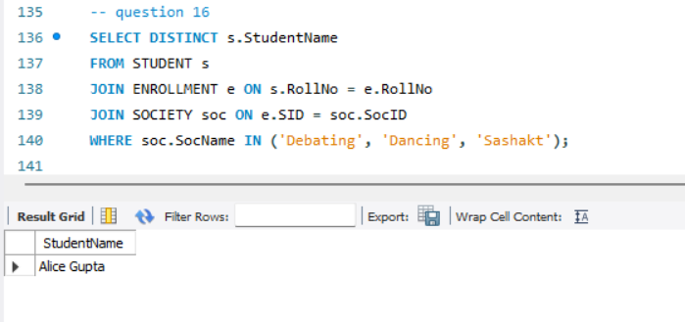

Question 17
Find society names such that its mentor has a name with ‘Gupta’ in it.
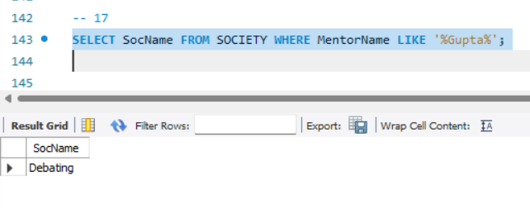

Question 18
Find the society names in which the number of enrolled students is only 10% of its capacity.
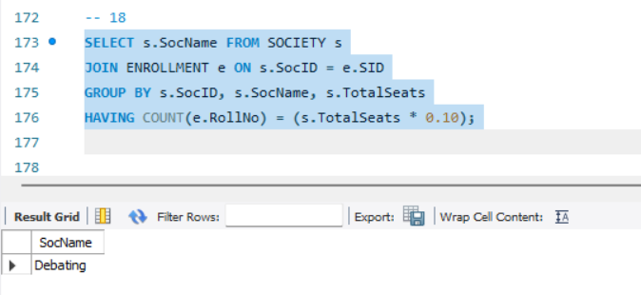
Question 19
Display the vacant seats for each society.
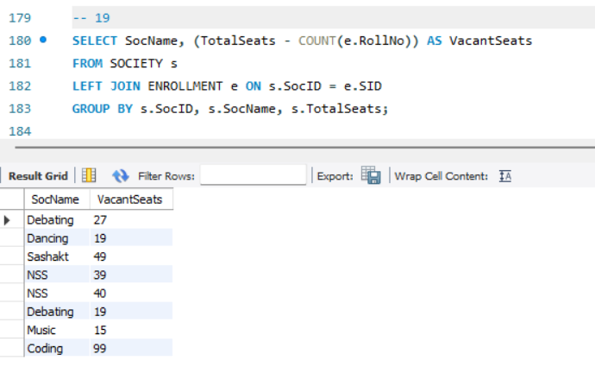

Question 20
Increment Total Seats of each society by 10%.

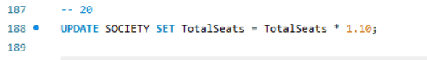

Question 21
Add the enrollment fees paid (‘yes’/’No’) field in the enrollment table.
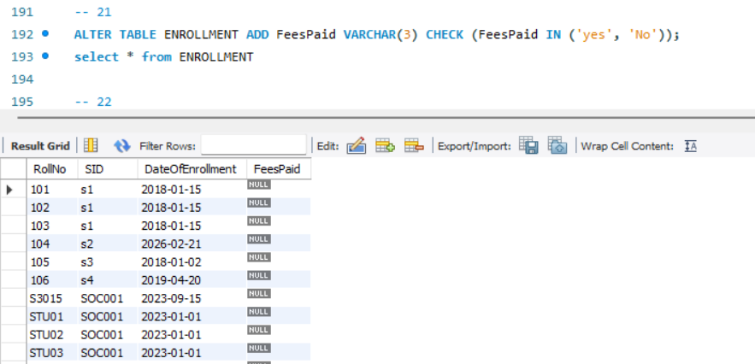

Question 22
Update date of enrollment of society id ‘s1’ to ‘2018-01-15’, ‘s2’ to current date and ‘s3’ to ‘2018-01-02’.

UPDATE ENROLLMENT SET DateOfEnrollment = '2018-01-15' WHERE SID = 's1';
UPDATE ENROLLMENT SET DateOfEnrollment = CURDATE() WHERE SID = 's2';
UPDATE ENROLLMENT SET DateOfEnrollment = '2018-01-02' WHERE SID = 's3';

Question 24
Find student names enrolled in all the societies.
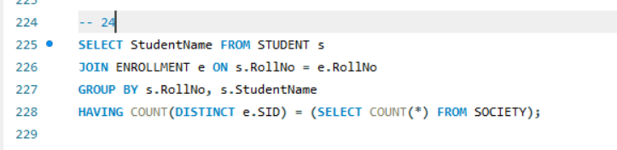

Question 25
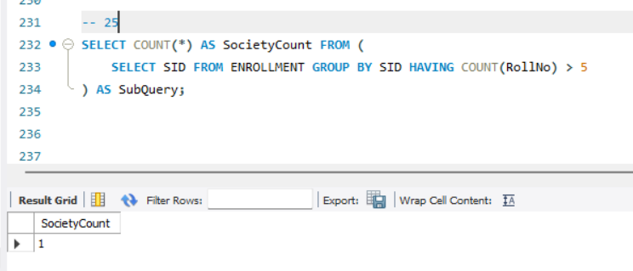Count the number of societies with more than 5 students enrolled in it.

